**SECURING DATA WITH BLOCKCHAIN AND AI – SECNET**

Hari Varma Nagaraju (Y00869461)

Tarun Kumar Reddy Mulagani (Y00870434)

Naveen Maddula (Y00869131)

Department of Computer science and Information Systems

Youngstown State University

CSCI.6991.43545 Data Engineering Capstone

Instructor: Dr. Feng George Yu

Project Advisor: Dr. Robert A. Gilliland

December 4, 2024

**SECURING DATA WITH BLOCKCHAIN AND AI - SECNET**

**ABSTRACT:**

Data is the input for various artificial intelligence (AI) algorithms to mine valuable features, but data on the Internet is dispersed and controlled by various stakeholders who do not trust one another, and it is challenging to authorize or validate the use of data in complex cyberspace. As a result, it is very difficult to enable data sharing in cyberspace for the real big data, as well as a real powerful AI. In this paper, we propose the SecNet, an architecture that can enable secure data storing, computing, and sharing in the large-scale Internet environment, aiming at a more secure cyberspace with real big data and thus enhanced AI with plenty of data source, by integrating three key components:

1) Real big data can be formed through trusted data sharing in a large-scale setting thanks to blockchain-based data sharing with ownership assurance.

2) AI-based secure computing platform to produce more intelligent security rules, which helps to construct a more trusted cyberspace.

3) trusted value-exchange mechanism for purchasing security service, providing a way for participants to gain economic rewards when giving out their data or service, which promotes the data sharing and thus achieves better performance of AI.

Moreover, we discuss the typical use scenario of SecNet as well as its potentially alternative way to deploy, as well as analyze its effectiveness from the aspect of network security and economic revenue.

**INDEX TERMS** : Data security, data systems, artificial intelligence, cyberspace

**CHAPTER 1**

**INTRODUCTION**

The trend of combining cyber, physical, and social (CPS) systems into a highly integrated information society rather than only a digital Internet is becoming more and more apparent as information technologies advance. Data is the property of its owner in such an information society, and although this is not always the case, the owner should have complete control over how it is used. Almost all large companies seek to gather as much data as they can for their future competitiveness because data is unquestionably the lifeblood of the information society. Built-in sensors in those large corporations' devices are secretly collecting an increasing quantity of personal data, such as location data, web browsing habits, user calls, and user preferences. This poses a serious risk to data owners' privacy. Additionally, the owners have no control over how those data are used because there is currently no trustworthy mechanism to track down who uses the data and how, making it difficult to identify and punish those who misuse it. In other words, it is very difficult for an individual to handle the possible hazards associated with the obtained data if they are unable to manage it efficiently. Lack of access to data gathered by a third party (such as a large corporation) can make it difficult for an individual to comprehend or control the hazards associated with the information that has been obtained from him. Meanwhile, the lack of immutable recording for the usage of data increases the risks to abuse them. If there is an efficient and trusted way to collect and merge the data scattered across the whole CPS to form real big data, the performance of artificial intelligence (AI) will be significantly improved since AI can handle massive amount of data including huge information at the same time, which would bring in great benefits (e.g., achieving enhanced security for data) and even makes AI gaining the ability to exceed human capabilities in more areas.

According to the research in, if given large amount of data in an orders of magnitude more scale, even the simplest AI algorithm currently (e.g., perceptrons from the 1950s) can achieve fanciest performance to beat many state-of-the-art technologies today. The key lies in how to make data sharing trusted and secured. Fortunately, the blockchain technologies may be the promising way to achieve this goal, via consensus mechanisms throughout the network to guarantee data sharing in a tamper-proof way embedded with economic incentives. Thus, AI can be further empowered by blockchainprotected data sharing. As a result, enhanced AI can provide better performance and security for data. In this paper, we aim at securing data by combining blockchain and AI together, and design a Secure Networking architecture (termed as SecNet) to significantly improve the security of data sharing, and then the security of the whole network, even the whole CPS. In SecNet, to protect data, one of the biggest challenges is where and how to store data, because users must give their data to service providers if they want to use certain services or applications.

his is caused by the inherent coupling of user data and application in current service mechanisms, which significantly hinders the development of data protection and application innovation. Inspired by the concept of Personal Data Store (PDS) from openPDS and the Private Data Center (PDC) from HyperNet, SecNet finally inherits and adopts PDC instead of PDS, as PDC is more suitable to deploy and to deal with this problem, since it provides more secure and intelligent data storage system via physical entities instead of software-based algorithms as in openPDS. Each PDC actually serves as a secured as well as centralized physical space for each SecNet user where his/her data lives in. Embedding PDC into SecNet would allow users to monitor and reason about what and why their data is used as well as by who, meaning the users can truly control every operation on their own data and achieve fine-grained management on access behaviors for data. Actually, besides PDC, other choices can also be applied for the data storing in SecNet according to certain requirements (see Section V).

The trust-less relationship between different data stakeholders significantly thwarts the data sharing in the whole Internet, thus the data used for AI training or analyzing is limited in amount as well as partial in variety. Fortunately, the rise of Block chain technologies bring in a hopeful, efficient and effective way to enable trust data sharing in trustless environment, which can help AI make more accurate decisions due to the real big data collected from more places in the Internet. SecNet leverages the emerging blockchain technologies to prevent the abuse of data, and to enable trusted data sharing in trust-less or even untrusted environment. For instance, it can enable cooperations between different edge computing paradigms to work together to improve the whole system performance of edge networks. The reason why blockchain can enable trusted mechanisms is that it can provide a transparent, tamper-proof metadata infrastructure to seriously recode all the usage of data. Thus, SecNet introduces blockchain-based data sharing mechanisms with ownership guarantee, where any data ready for sharing should be registered into a blockchain, named Data Recording Blockchain (DRB), to announce its availability for sharing. Each access behavior on data by other parties (not the data owner) should also be validated and recorded in this chain. In addition, the authenticity and integrity of data can only be validated by DRB as well. Besides, SecNet enables economic incentive between different entities if they share data or exchange security service, by embedding smart contract on data to trigger automatic and tamper-proof value exchange.

In this way, SecNet guarantees the data security and encourages data sharing throughout the CPS. Furthermore, data is the fuel of AI, and it can greatly help to improve the performance of AI algorithms if data can be efficiently networked and properly fused. Enabling data sharing across multiple service providers can be a way to maximize the utilization of scattered data in separate entities with potential conflicts of interest, which can enables a more powerful AI. Given enough data and blockchain based smart contract on secure data sharing, it is not surprised that AI can become one of the most powerful technologies and tools to improve cybersecurity, since it can check huge amount of data more quickly to save time, and identify and mitigate threats more rapidly, and meanwhile give more accurate prediction and decision support on security rules that a PDC should deploy. Besides, embedded with Machine Learning inside, AI can constantly learn patterns by applying existing data or artificial data generated by GAN to improve its strategies over time, to strengthen its ability on identifying any deviation on data or behaviors on a 24/7/365 basis. SecNet can apply these advanced AI technologies into its Operation Support System (OSS) to adaptively identify more suspicious data-related behaviors, even they are never seen before. In addition, swarm intelligence can be used in SecNet to further improve the data security, by collecting different security knowledge from huge amount of intelligent agents scattered everywhere in the CPS, with the help of trusted exchange mechanisms for incentive tokens.

**CHAPTER 2**

**LITERATURE SURVEY**

**H. Yin, D. Guo, K. Wang, Z. Jiang, Y. Lyu, and J. Xing, ‘‘Hyperconnected network: A decentralized trusted computing and networking paradigm,’’ IEEE Netw., vol. 32, no. 1, pp. 112–117, Jan./Feb. 2018**

With the development of the Internet of Things, a complex CPS system has emerged and is becoming a promising information infrastructure. In the CPS system, the loss of control over user data has become a very serious challenge, making it difficult to protect privacy, boost innovation, and guarantee data sovereignty. In this article, we propose HyperNet, a novel decentralized trusted computing and networking paradigm, to meet the challenge of loss of control over data. HyperNet is composed of the intelligent PDC, which is considered as the digital clone of a human individual; the decentralized trusted connection between any entities based on blockchain as well as smart contract; and the UDI platform, enabling secure digital object management and an identifier-driven routing mechanism. HyperNet has the capability of protecting data sovereignty, and has the potential to transform the current communication-based information system to the future data-oriented information society.

**K. Fan, W. Jiang, H. Li, and Y. Yang, ‘‘Lightweight RFID protocol for medical privacy protection in IoT,’’ IEEE Trans Ind. Informat., vol. 14, no. 4, pp. 1656–1665, Apr. 2018**

Traditional medical privacy data are at a serious risk of disclosure, and many related cases have occurred over the years. For example, personal medical privacy data can be easily leaked to insurance companies, which not only compromises the privacy of individuals, but also hinders the healthy development of the medical industry. With the continuous improvement of cloud computing and big data technologies, the Internet of Things technology has been rapidly developed. Radio frequency identification (RFID) is one of the core technologies of the Internet of Things. The application of the RFID system to the medical system can effectively solve this problem of medical privacy. RFID tags in the system can collect useful information and conduct data exchange and processing with a back-end server through the reader. The whole process of information interaction is mainly in the form of ciphertext. In the context of the Internet of Things, the paper presents a lightweight RFID medical privacy protection scheme. The scheme ensures security privacy of the collected data via secure authentication. The security analysis and evaluation of the scheme indicate that the protocol can effectively prevent the risk of medical privacy data being easily leaked.

**T. Chajed, J. Gjengset, J. Van Den Hooff, M. F. Kaashoek, J. Mickens, R. Morris, and N. Zeldovich, ‘‘Amber: Decoupling user data from Web applications,’’ in Proc. 15th Workshop Hot Topics Oper. Syst. (HotOS XV), Warth-Weiningen, Switzerland, 2015, pp. 1–6.**

Modern web services rob users of low-level control over cloud storage—a user’s single logical data set is scattered across multiple storage silos whose access controls are set by web services, not users. The consequence is that users lack the ultimate authority to determine how their data is shared with other web services. In this paper, we introduce Sieve, a new platform which selectively (and securely) exposes user data to web services. Sieve has a user-centric storage model: each user uploads encrypted data to a single cloud store, and by default, only the user knows the decryption keys. Given this storage model, Sieve defines an infrastructure to support rich, legacy web applications. Using attribute-based encryption, Sieve allows users to define intuitively understandable access policies that are cryptographically enforceable. Using key homomorphism, Sieve can reencrypt user data on storage providers in situ, revoking decryption keys from web services without revealing new keys to the storage provider. Using secret sharing and two-factor authentication, Sieve protects cryptographic secrets against the loss of user devices like smartphones and laptops. The result is that users can enjoy rich, legacy web applications, while benefiting from cryptographically strong controls over which data a web service can access

**M. Lecuyer, R. Spahn, R. Geambasu, T.-K. Huang, and S. Sen, ‘‘Enhancing selectivity in big data,’’ IEEE Security Privacy, vol. 16, no. 1, pp. 34–42, Jan./Feb. 2018**

Protecting vast quantities of data poses a daunting challenge for the growing number of organizations that collect, stockpile, and monetize it. The ability to distinguish data that is actually needed from data collected "just in case" would help these organizations to limit the latter's exposure to attack. A natural approach might be to monitor data use and retain only the working-set of in-use data in accessible storage; unused data can be evicted to a highly protected store. However, many of today's big data applications rely on machine learning (ML) workloads that are periodically retrained by accessing, and thus exposing to attack, the entire data store. Training set minimization methods, such as count featurization, are often used to limit the data needed to train ML workloads to improve performance or scalability. We present Pyramid, a limited-exposure data management system that builds upon count featurization to enhance data protection. As such, Pyramid uniquely introduces both the idea and proof-of-concept for leveraging training set minimization methods to instill rigor and selectivity into big data management. We integrated Pyramid into Spark Velox, a framework for ML-based targeting and personalization. We evaluate it on three applications and show that Pyramid approaches state-of-the-art models while training on less than 1% of the raw data.

**Y.-A. de Montjoye, E. Shmueli, S. S. Wang, and A. S. Pentland, ‘‘openPDS: Protecting the privacy of metadata through Safe Answers,’’ PLoS ONE, vol. 9, no. 7, 2014, Art. no. e98790**

The rise of smartphones and web services made possible the large-scale collection of personal metadata. Information about individuals' location, phone call logs, or web-searches, is collected and used intensively by organizations and big data researchers. Metadata has however yet to realize its full potential. Privacy and legal concerns, as well as the lack of technical solutions for personal metadata management is preventing metadata from being shared and reconciled under the control of the individual. This lack of access and control is furthermore fueling growing concerns, as it prevents individuals from understanding and managing the risks associated with the collection and use of their data. Our contribution is two-fold: (1) we describe openPDS, a personal metadata management framework that allows individuals to collect, store, and give fine-grained access to their metadata to third parties. It has been implemented in two field studies; (2) we introduce and analyze SafeAnswers, a new and practical way of protecting the privacy of metadata at an individual level. SafeAnswers turns a hard anonymization problem into a more tractable security one. It allows services to ask questions whose answers are calculated against the metadata instead of trying to anonymize individuals' metadata. The dimensionality of the data shared with the services is reduced from high-dimensional metadata to low-dimensional answers that are less likely to be re-identifiable and to contain sensitive information. These answers can then be directly shared individually or in aggregate. openPDS and SafeAnswers provide a new way of dynamically protecting personal metadata, thereby supporting the creation of smart data-driven services and data science research.

**CHAPTER 3**

**SYSTEM ANALYSIS AND DESIGN**

**EXISTING SYSTEM**

Given data is undoubtedly the oil of the information society, almost every big company want to collect data as much as possible, for their future competitiveness. An increasing amount of personal data, including location information, web- searching behavior, user calls, user preference, is being silently collected by the built-in sensors inside the products from those big companies, which brings in huge risk on privacy leakage of data owners. Moreover, the usage of those data is out of control of their owners, since currently The associate editor coordinating the review of this manuscript and approving it for publication was Chi-Yuan Chen. there is not a reliable way to record how the data is used and by who, and thus has little methods to trace or punish the violators who abuse those data. That is, lack of ability to effectively manage data makes it very difficult for an individual to control the potential risks associated with the collected data. For example, once the data has been collected by a third party (e.g., a big company), the lack of access to this data hinders an individual to understand or manage the risks related to the collected data from him. Meanwhile, the lack of immutable recording for the usage of data increases the risks to abuse them.

**PROPOSED SYSTEM:**

we aim at securing data by combining blockchain and AI together, and design a Secure Networking architecture (termed as SecNet) to significantly improve the security of data sharing, and then the security of the whole network, even the whole CPS. In SecNet, to protect data, one of the biggest challenges is where and how to store data, because users must give their data to service providers if they want to use certain services or applications. This is caused by the inherent coupling of user data and application in current service mechanisms, which significantly hinders the development of data protection and application innovation. Inspired by the concept of Personal Data Store (PDS) from openPDS and the Private Data Center (PDC) from Hypernet, SecNet finally inherits and adopts PDC instead of PDS, as PDC is more suitable to deploy and to deal with this problem, since it provides more secure and intelligent data storage system via physical entities instead of software-based algorithms as in open PDS. Each PDC serves as a secured as well as centralized physical space for each SecNet user where his/her data lives in. Embedding PDC into SecNet would allow users to monitor and reason about what and why their data is used as well as by who, meaning the users can truly control every operation on their own data and achieve fine-grained management on access behaviors for data. Actually, besides PDC, other choices can also be applied for the data storing in SecNet according to certain requirement.

**SYSTEM DESIGN**

The elements are like components which can be associated in different ways to make a complete UML picture, which is known as diagram. Thus, it is very important to understand the different diagrams to implement the knowledge in real-life systems.

Any complex system is best understood by making some kind of diagrams or pictures. These diagrams have a better impact on our understanding. If we look around, we will realize that the diagrams are not a new concept but it is used widely in different forms in different industries.

We prepare UML diagrams to understand the system in a better and simple way. A single diagram is not enough to cover all the aspects of the system. UML defines various kinds of diagrams to cover most of the aspects of a system.

You can also create your own set of diagrams to meet your requirements. Diagrams are generally made in an incremental and iterative way.

There are two broad categories of diagrams and they are again divided into subcategories −

* Structural Diagrams
* Behavioral Diagrams

Structural Diagrams

The structural diagrams represent the static aspect of the system. These static aspects represent those parts of a diagram, which forms the main structure and are therefore stable.

These static parts are represented by classes, interfaces, objects, components, and nodes. The four structural diagrams are −

* Class diagram
* Object diagram
* Component diagram
* Deployment diagram

**SYSTEM ARCHITECTURE**

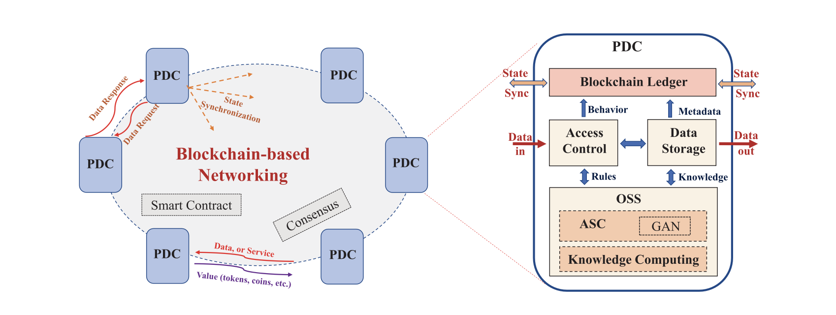

Source: K. Wang *et al.*: Securing Data with Blockchain and AI

**Class Diagram**

Class diagrams are the most common diagrams used in UML. Class diagram consists of classes, interfaces, associations, and collaboration. Class diagrams basically represent the object-oriented view of a system, which is static in nature.

Active class is used in a class diagram to represent the concurrency of the system.

Class diagram represents the object orientation of a system. Hence, it is generally used for development purpose. This is the most widely used diagram at the time of system construction.

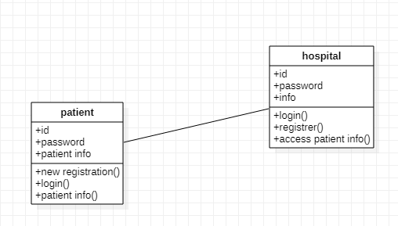

Object Diagram

Object diagrams can be described as an instance of class diagram. Thus, these diagrams are more close to real-life scenarios where we implement a system.

Object diagrams are a set of objects and their relationship is just like class diagrams. They also represent the static view of the system.

The usage of object diagrams is similar to class diagrams but they are used to build prototype of a system from a practical perspective.

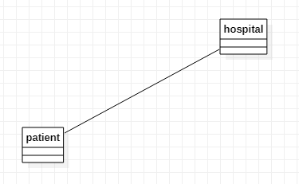

Component Diagram

Component diagrams represent a set of components and their relationships. These components consist of classes, interfaces, or collaborations. Component diagrams represent the implementation view of a system.

During the design phase, software artifacts (classes, interfaces, etc.) of a system are arranged in different groups depending upon their relationship. Now, these groups are known as components.

Finally, it can be said component diagrams are used to visualize the implementation.

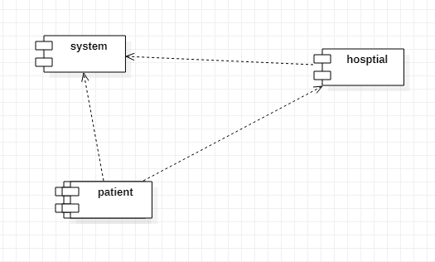

Deployment Diagram

Deployment diagrams are a set of nodes and their relationships. These nodes are physical entities where the components are deployed.

Deployment diagrams are used for visualizing the deployment view of a system. This is generally used by the deployment team.

**Note** − If the above descriptions and usages are observed carefully then it is very clear that all the diagrams have some relationship with one another. Component diagrams are dependent upon the classes, interfaces, etc. which are part of class/object diagram. Again, the deployment diagram is dependent upon the components, which are used to make component diagrams.

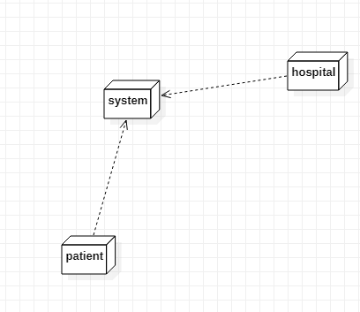

Behavioral Diagrams

Any system can have two aspects, static and dynamic. So, a model is considered as complete when both the aspects are fully covered.

Behavioral diagrams basically capture the dynamic aspect of a system. Dynamic aspect can be further described as the changing/moving parts of a system.

UML has the following five types of behavioral diagrams −

* Use case diagram
* Sequence diagram
* Collaboration diagram
* State chart diagram
* Activity diagram

**Use Case Diagram**

Use case diagrams are a set of use cases, actors, and their relationships. They represent the use case view of a system.

A use case represents a particular functionality of a system. Hence, use case diagram is used to describe the relationships among the functionalities and their internal/external controllers. These controllers are known as **actors**.

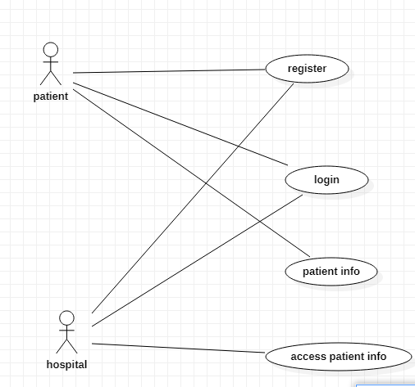

**Sequence Diagram**

A sequence diagram is an interaction diagram. From the name, it is clear that the diagram deals with some sequences, which are the sequence of messages flowing from one object to another.

Interaction among the components of a system is very important from implementation and execution perspective. Sequence diagram is used to visualize the sequence of calls in a system to perform a specific functionality.

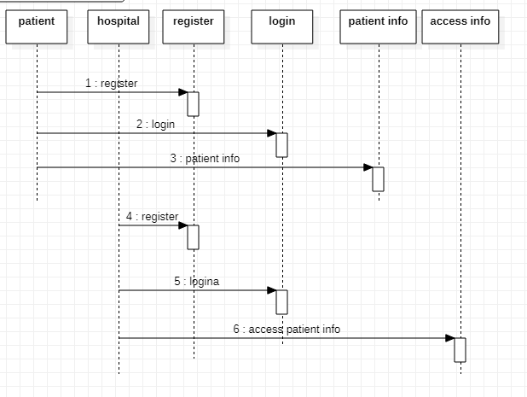

**Collaboration Diagram**

Collaboration diagram is another form of interaction diagram. It represents the structural organization of a system and the messages sent/received. Structural organization consists of objects and links.

The purpose of collaboration diagram is similar to sequence diagram. However, the specific purpose of collaboration diagram is to visualize the organization of objects and their interaction.

State chart Diagram

Any real-time system is expected to be reacted by some kind of internal/external events. These events are responsible for state change of the system.

State chart diagram is used to represent the event driven state change of a system. It basically describes the state change of a class, interface, etc.

State chart diagram is used to visualize the reaction of a system by internal/external factors.

**Patient state chart diagram**

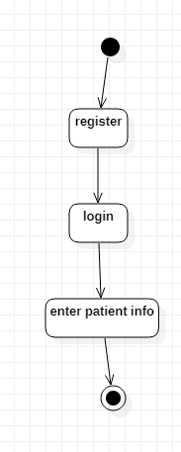

**Hospital state chart diagram**

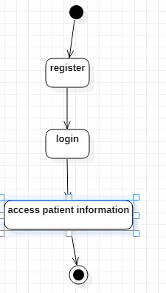

**Activity Diagram**

Activity diagram describes the flow of control in a system. It consists of activities and links. The flow can be sequential, concurrent, or branched.

Activities are nothing but the functions of a system. Numbers of activity diagrams are prepared to capture the entire flow in a system.

Activity diagrams are used to visualize the flow of controls in a system. This is prepared to have an idea of how the system will work when executed.

**Note** − Dynamic nature of a system is very difficult to capture. UML has provided features to capture the dynamics of a system from different angles. Sequence diagrams and collaboration diagrams are isomorphic, hence they can be converted from one another without losing any information. This is also true for State chart and activity diagram

Class diagram is a static diagram. It represents the static view of an application. Class diagram is not only used for visualizing, describing, and documenting different aspects of a system but also for constructing executable code of the software application.

Class diagram describes the attributes and operations of a class and also the constraints imposed on the system. The class diagrams are widely used in the modeling of objectoriented systems because they are the only UML diagrams, which can be mapped directly with object-oriented languages.

Class diagram shows a collection of classes, interfaces, associations, collaborations, and constraints. It is also known as a structural diagram.

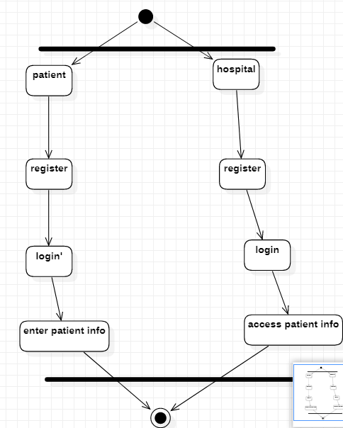

## Purpose of Class Diagrams

The purpose of class diagram is to model the static view of an application. Class diagrams are the only diagrams which can be directly mapped with object-oriented languages and thus widely used at the time of construction.

UML diagrams like activity diagram, sequence diagram can only give the sequence flow of the application, however class diagram is a bit different. It is the most popular UML diagram in the coder community.

The purpose of the class diagram can be summarized as −

* Analysis and design of the static view of an application.
* Describe responsibilities of a system.
* Base for component and deployment diagrams.
* Forward and reverse engineering.

**INPUT AND OUTPUT DESIGN**

**INPUT DESIGN**

The input design is the link between the information system and the user. It comprises the developing specification and procedures for data preparation and those steps are necessary to put transaction data in to a usable form for processing can be achieved by inspecting the computer to read data from a written or printed document or it can occur by having people keying the data directly into the system. The design of input focuses on controlling the amount of input required, controlling the errors, avoiding delay, avoiding extra steps and keeping the process simple. The input is designed in such a way so that it provides security and ease of use with retaining the privacy. Input Design considered the following things:

* What data should be given as input?
* How the data should be arranged or coded?
* The dialog to guide the operating personnel in providing input.
* Methods for preparing input validations and steps to follow when error occur.

**OBJECTIVES**

1.Input Design is the process of converting a user-oriented description of the input into a computer-based system. This design is important to avoid errors in the data input process and show the correct direction to the management for getting correct information from the computerized system.

2. It is achieved by creating user-friendly screens for the data entry to handle large volume of data. The goal of designing input is to make data entry easier and to be free from errors. The data entry screen is designed in such a way that all the data manipulates can be performed. It also provides record viewing facilities.

3.When the data is entered it will check for its validity. Data can be entered with the help of screens. Appropriate messages are provided as when needed so that the user will not be in maize of instant. Thus the objective of input design is to create an input layout that is easy to follow

**OUTPUT DESIGN**

A quality output is one, which meets the requirements of the end user and presents the information clearly. In any system results of processing are communicated to the users and to other system through outputs. In output design it is determined how the information is to be displaced for immediate need and also the hard copy output. It is the most important and direct source information to the user. Efficient and intelligent output design improves the system’s relationship to help user decision-making.

1. Designing computer output should proceed in an organized, well thought out manner; the right output must be developed while ensuring that each output element is designed so that people will find the system can use easily and effectively. When analysis design computer output, they should Identify the specific output that is needed to meet the requirements.

2.Select methods for presenting information.

3.Create document, report, or other formats that contain information produced by the system.

The output form of an information system should accomplish one or more of the following objectives.

* Convey information about past activities, current status or projections of the
* Future.
* Signal important events, opportunities, problems, or warnings.
* Trigger an action.
* Confirm an action.

**CHAPTER 4**

**IMPLEMENTATION**

**Modules Information:**

This project consists of two modules

1. **Patients:** Patients first create his profile with all disease details and then select desired hospital with whom he wishes to share/subscribe data. While creating profile application will create Blockchain object with allowable permission and it will allow only those hospitals to access data.

Patient Login: Patient can login to application with his profile id and check total rewards he earned from sharing data.

1. **Hospital:** Hospital1 and Hospital2 are using in this application as two organizations with whom patient can share data. At a time, any hospital can login to application and then enter search string as disease name.

AI algorithm will take input disease string and then perform search operation on all patients to get similar disease patients and then check whether this hospital has permission to access that patient data or not, if hospital has access permission then it will display those patients records to that hospital.

**CHAPTER 5**

**SYSTEM STUDY & TESTING**

**FEASIBILITY STUDY**

The feasibility of the project is analyzed in this phase and business proposal is put forth with a very general plan for the project and some cost estimates. During system analysis the feasibility study of the proposed system is to be carried out. This is to ensure that the proposed system is not a burden to the company. For feasibility analysis, some understanding of the major requirements for the system is essential.

**Three key considerations involved in the feasibility analysis are,**

* **ECONOMICAL FEASIBILITY**
* **TECHNICAL FEASIBILITY**
* **SOCIAL FEASIBILITY**

**ECONOMICAL FEASIBILITY**

This study is carried out to check the economic impact that the system will have on the organization. The amount of fund that the company can pour into the research and development of the system is limited. The expenditures must be justified. Thus the developed system as well within the budget and this was achieved because most of the technologies used are freely available. Only the customized products had to be purchased.

### TECHNICAL FEASIBILITY

This study is carried out to check the technical feasibility, that is, the technical requirements of the system. Any system developed must not have a high demand on the available technical resources. This will lead to high demands on the available technical resources. This will lead to high demands being placed on the client. The developed system must have a modest requirement, as only minimal or null changes are required for implementing this system.

**SOCIAL FEASIBILITY**

The aspect of study is to check the level of acceptance of the system by the user. This includes the process of training the user to use the system efficiently. The user must not feel threatened by the system, instead must accept it as a necessity. The level of acceptance by the users solely depends on the methods that are employed to educate the user about the system and to make him familiar with it. His level of confidence must be raised so that he is also able to make some constructive criticism, which is welcomed, as he is the final user of the system.

**SYSTEM TEST**

The purpose of testing is to discover errors. Testing is the process of trying to discover every conceivable fault or weakness in a work product. It provides a way to check the functionality of components, sub-assemblies, assemblies and/or a finished product It is the process of exercising software with the intent of ensuring that the Software system meets its requirements and user expectations and does not fail in an unacceptable manner. There are various types of test. Each test type addresses a specific testing requirement.

### TYPES OF TESTS

**Unit testing**

Unit testing involves the design of test cases that validate that the internal program logic is functioning properly, and that program inputs produce valid outputs. All decision branches and internal code flow should be validated. It is the testing of individual software units of the application .it is done after the completion of an individual unit before integration. This is a structural testing, that relies on knowledge of its construction and is invasive. Unit tests perform basic tests at component level and test a specific business process, application, and/or system configuration. Unit tests ensure that each unique path of a business process performs accurately to the documented specifications and contains clearly defined inputs and expected results.

**Integration testing**

Integration tests are designed to test integrated software components to determine if they actually run as one program. Testing is event driven and is more concerned with the basic outcome of screens or fields. Integration tests demonstrate that although the components were individually satisfaction, as shown by successfully unit testing, the combination of components is correct and consistent. Integration testing is specifically aimed at exposing the problems that arise from the combination of components.

**Functional test**

Functional tests provide systematic demonstrations that functions tested are available as specified by the business and technical requirements, system documentation, and user manuals.

Functional testing is centered on the following items:

Valid Input : identified classes of valid input must be accepted.

Invalid Input : identified classes of invalid input must be rejected.

Functions : identified functions must be exercised.

Output : identified classes of application outputs must be exercised.

Systems/Procedures: interfacing systems or procedures must be invoked.

Organization and preparation of functional tests is focused on requirements, key functions, or special test cases. In addition, systematic coverage pertaining to identify Business process flows; data fields, predefined processes, and successive processes must be considered for testing. Before functional testing is complete, additional tests are identified and the effective value of current tests is determined.

**System Test**

System testing ensures that the entire integrated software system meets requirements. It tests a configuration to ensure known and predictable results. An example of system testing is the configuration oriented system integration test. System testing is based on process descriptions and flows, emphasizing pre-driven process links and integration points.

**White Box Testing**

White Box Testing is a testing in which in which the software tester has knowledge of the inner workings, structure and language of the software, or at least its purpose. It is purpose. It is used to test areas that cannot be reached from a black box level.

**Black Box Testing**

Black Box Testing is testing the software without any knowledge of the inner workings, structure or language of the module being tested. Black box tests, as most other kinds of tests, must be written from a definitive source document, such as specification or requirements document, such as specification or requirements document. It is a testing in which the software under test is treated, as a black box. you cannot “see” into it. The test provides inputs and responds to outputs without considering how the software works.

**Unit Testing**

Unit testing is usually conducted as part of a combined code and unit test phase of the software lifecycle, although it is not uncommon for coding and unit testing to be conducted as two distinct phases.

**Test strategy and approach**

Field testing will be performed manually and functional tests will be written in detail.

**Test objectives**

* All field entries must work properly.
* Pages must be activated from the identified link.
* The entry screen, messages and responses must not be delayed.

**Features to be tested**

* Verify that the entries are of the correct format
* No duplicate entries should be allowed
* All links should take the user to the correct page.

# Integration Testing

Software integration testing is the incremental integration testing of two or more integrated software components on a single platform to produce failures caused by interface defects.

The task of the integration test is to check that components or software applications, e.g. components in a software system or – one step up – software applications at the company level – interact without error.

**Test Results:** All the test cases mentioned above passed successfully. No defects encountered.

**Acceptance Testing**

User Acceptance Testing is a critical phase of any project and requires significant participation by the end user. It also ensures that the system meets the functional requirements.

**Test Results:** All the test cases mentioned above passed successfully. No defects encountered.

**CHAPTER 6**

**SCREEN SHOTS**

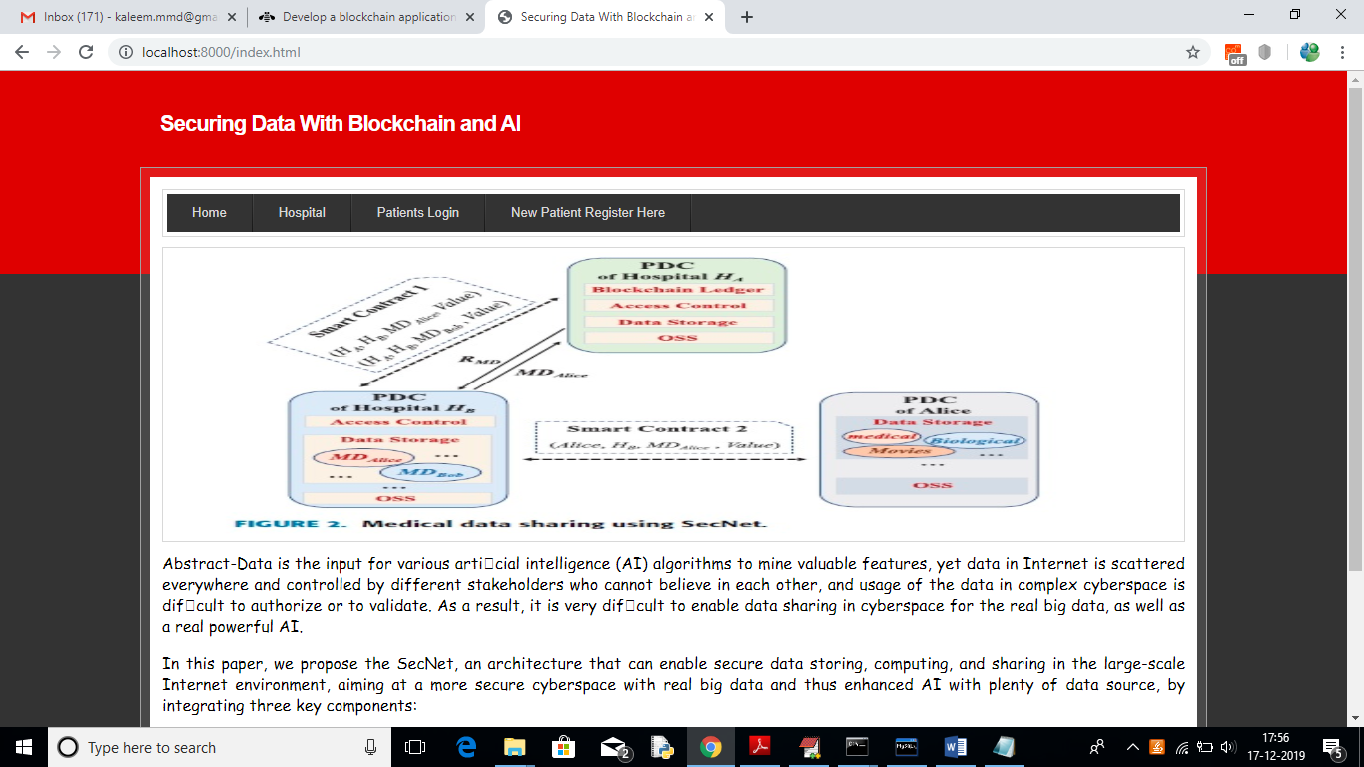

In above screen click on ‘New Patient Register Here’ link to get below screen

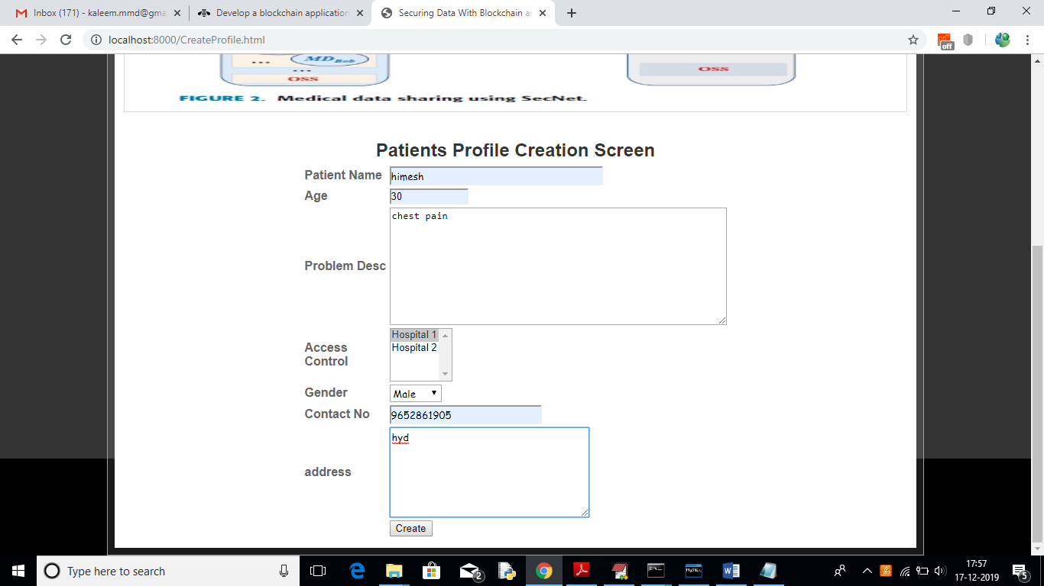

In above screen I am adding patient disease details and selecting ‘Hospital1’ to share my data and if you want to share with two hospitals then hold ‘CTRL’ key and select both hospitals to give permission. Now press ‘Create’ button to create profile

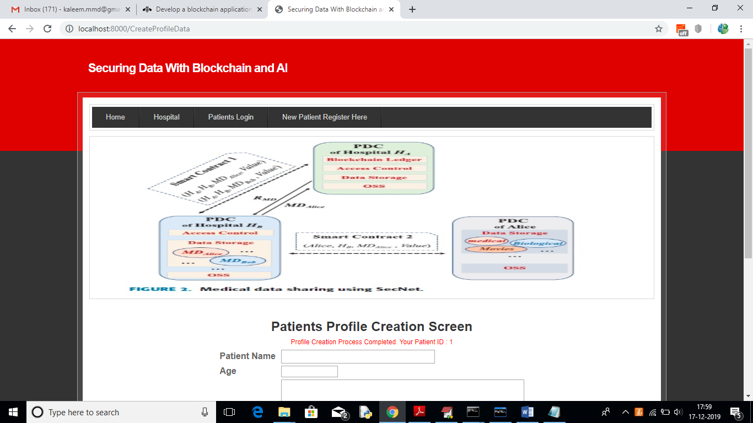

In above screen one patient is created with patient ID 1 and now Hospital 1 can login and search and access this patient data as patient has given permission to Hospital1

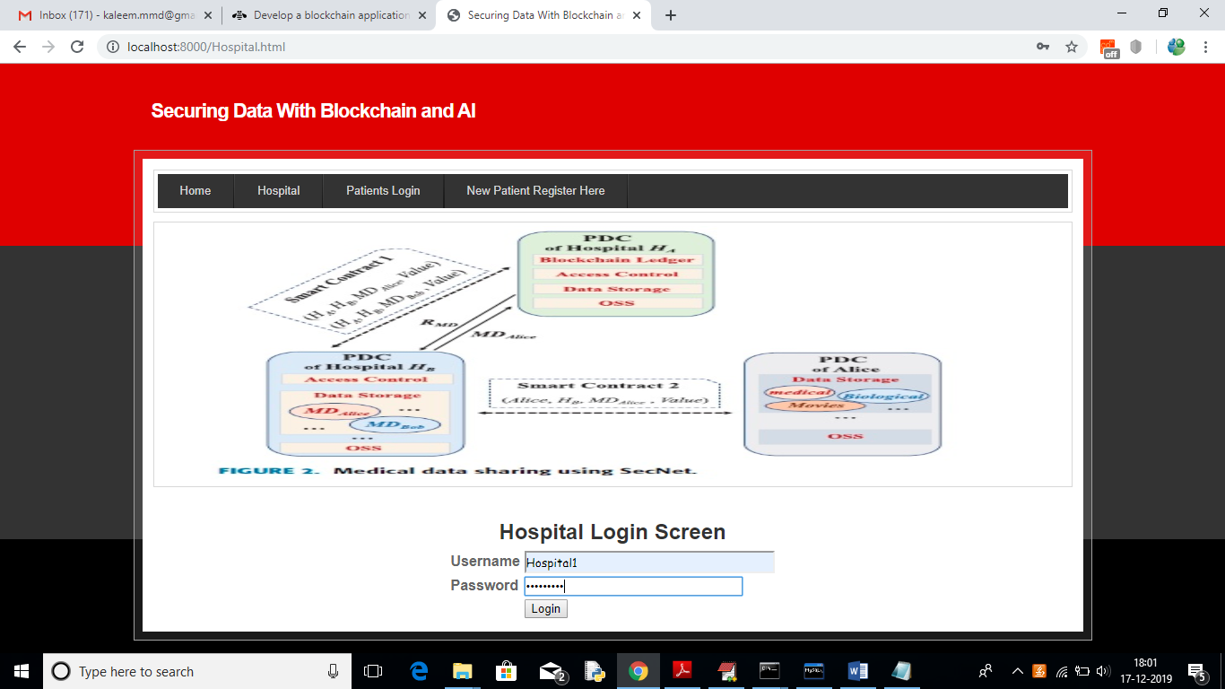

In above screen to login as Hospital1 click on ‘Hospital’ link to get above screen. Use ‘Hospital1’ as username and ‘Hospital1’ as password to login as Hospital1 and use Hospital2 to login as Hospital2. After login will get below screen

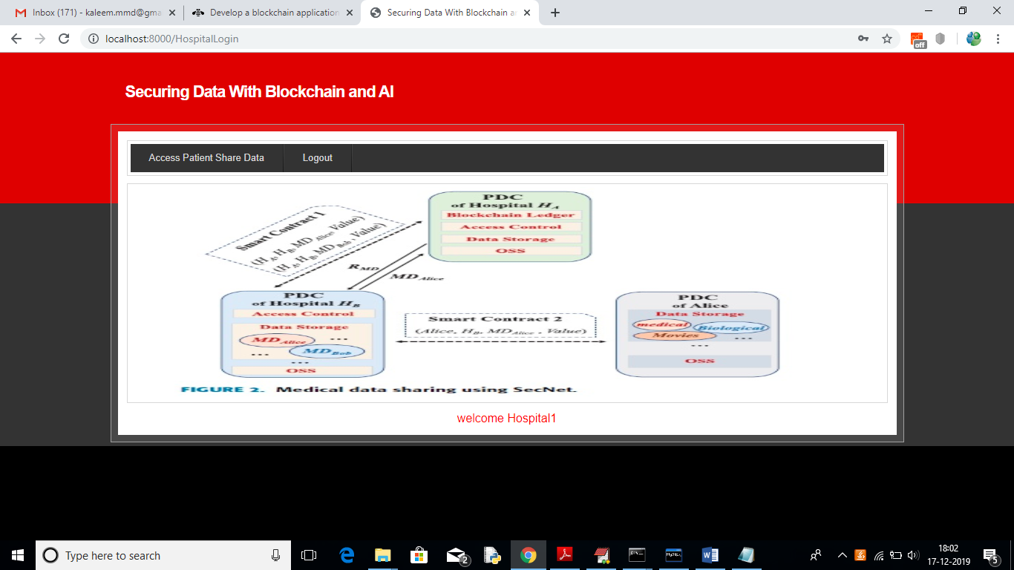

In above screen click on ‘Access Patient Share Data’ link to search for patient details

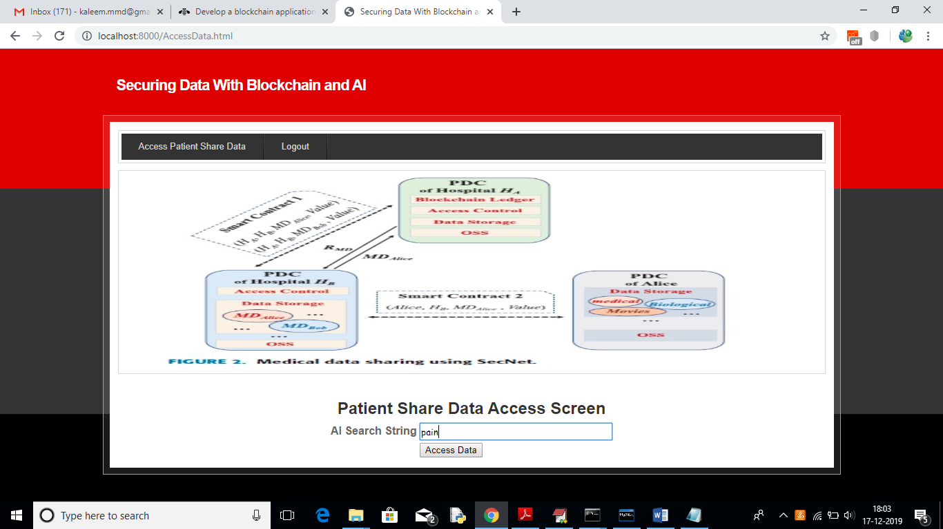

In above screen I want to search for all patients who are suffering from ‘pain’ and then click on ‘Access data’ button to get below screen

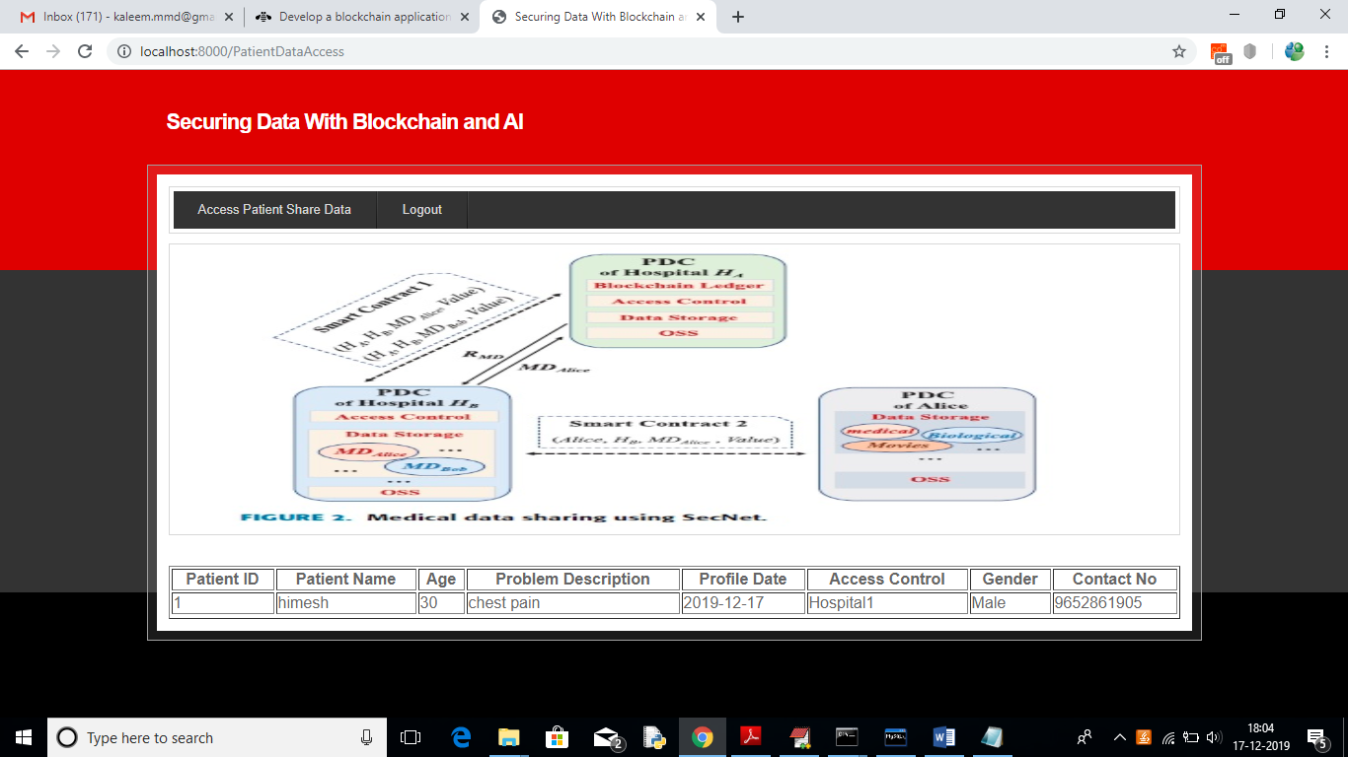

In above screen Hospital1 getting details of patient and Hospital2 not having permission so it will not get details. To see this logout and login as ‘Hospital2’

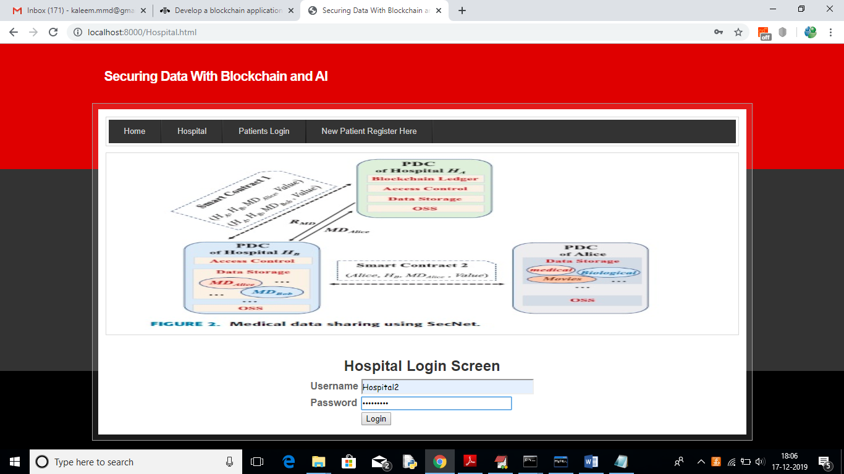

In above screen ‘Hospital2’ is login, after login will get below screen

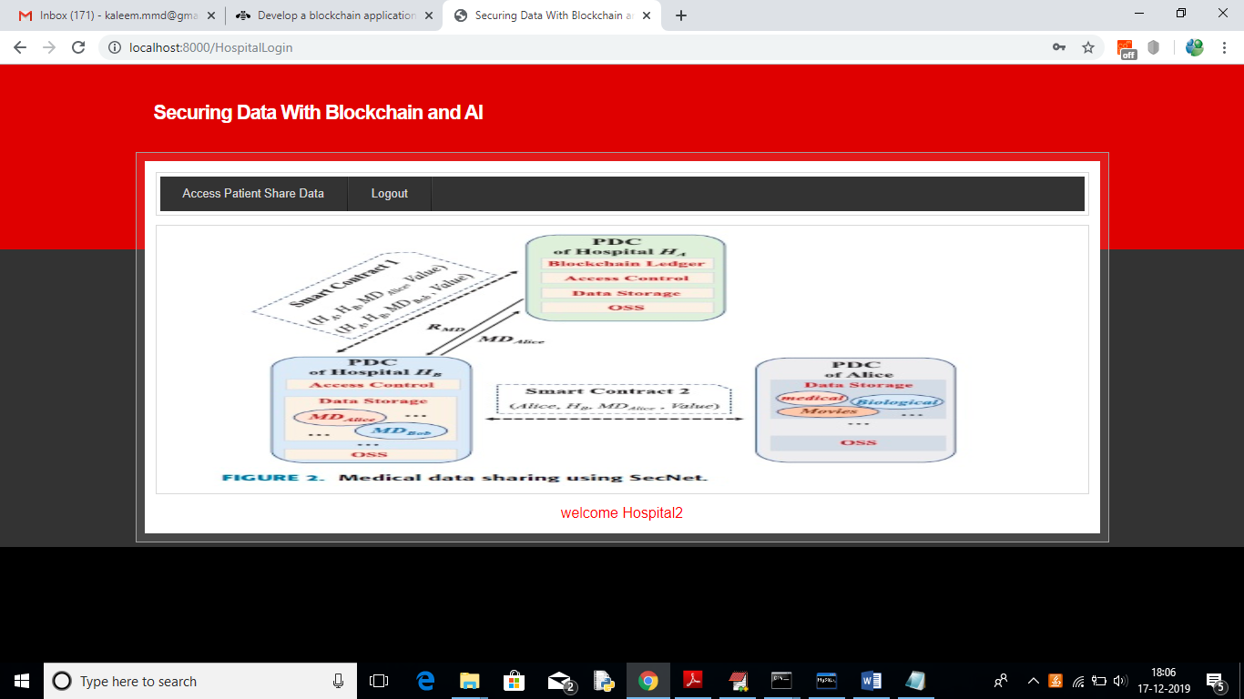

Now click on ‘Access Patient Share Data’ link and search for same pain disease

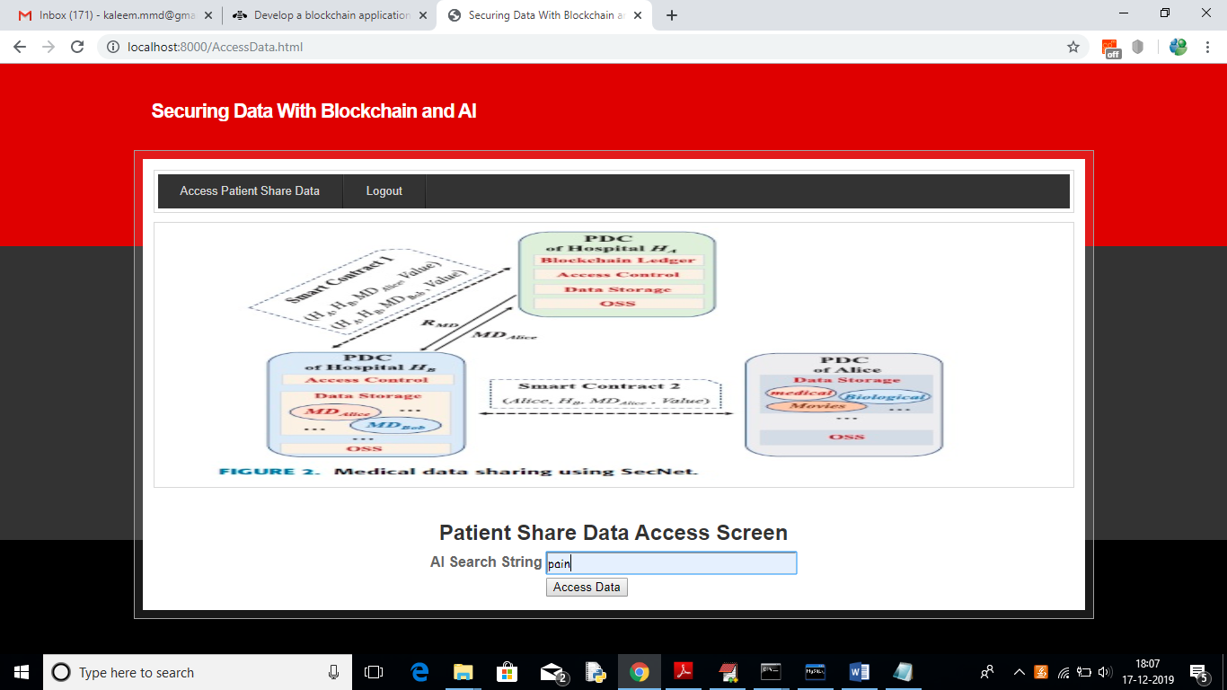

For above query will get below result

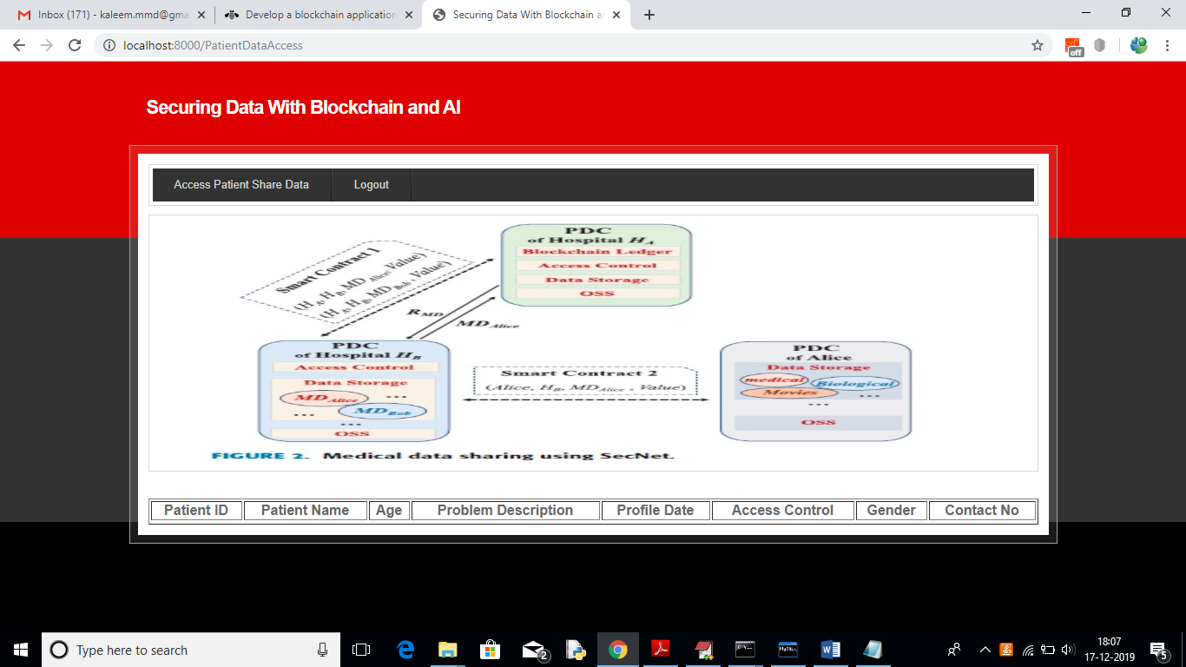

In above screen no patient details are showing as Hospital2 not having permission. So block chain allow only those users to access data who has permission. Now logout and login as patient by entering patient id in below screen

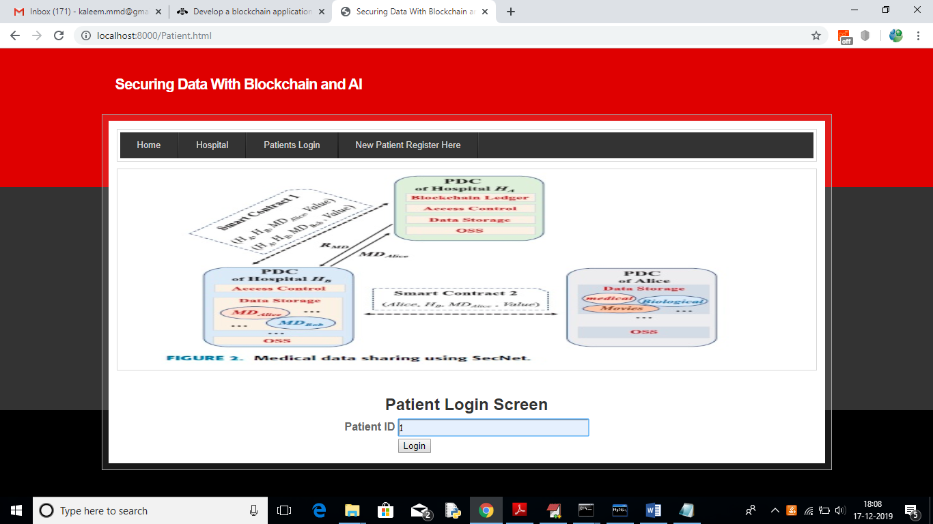

After login will get below details for patient 1

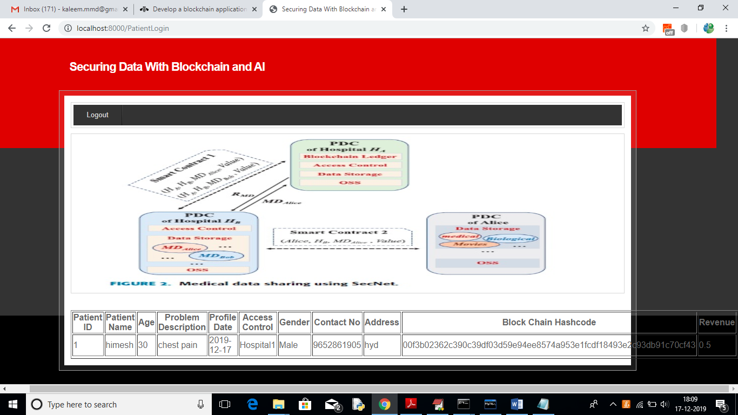

In above screen we can see patient all details and hash code generated by block chain and in last column we can see patient reward revenue as 0.5 and it will get update upon every access from hospital user.

**CHAPTER 7**

**CONCLUSION**

In order to leverage AI and blockchain to fit the problem of abusing data, as well as empower AI with the help of blockchain for trusted data management in trust-less environment, we propose the SecNet, which is a new networking paradigm focusing on secure data storing, sharing and computing instead of communicating. SecNet provides data ownership guaranteeing with the help of blockchain technologies, and AI-based secure computing platform as well as blockchain-based incentive mechanism, offering paradigm and incentives for data merging and more powerful AI to finally achieve better network security. Moreover, we discuss the typical use scenario of SecNet in medical care system, and gives alternative ways for employing the storage function of SecNet. Furthermore, we evaluate its improvement on network vulnerability when countering DDoS attacks, and analyze the inventive aspect on encouraging users to share security rules for a more secure network. In future work, we will explore how to leverage blockchain for the access authorization on data requests, and design secure and detailed smart contracts for data sharing and AI-based computing service in SecNet. In addition, we will model SecNet and analyze its performance through extensive experiments based on advanced platforms (e.g., integrating IPFS and Ethereum to form a SecNet-like architecture).

**REFERENCES**

[1] H. Yin, D. Guo, K. Wang, Z. Jiang, Y. Lyu, and J. Xing, ‘‘Hyperconnected network: A decentralized trusted computing and networking paradigm,’’ IEEE Netw., vol. 32, no. 1, pp. 112–117, Jan./Feb. 2018.

[2] K. Fan, W. Jiang, H. Li, and Y. Yang, ‘‘Lightweight RFID protocol for medical privacy protection in IoT,’’ IEEE Trans Ind. Informat., vol. 14, no. 4, pp. 1656–1665, Apr. 2018.

[3] T. Chajed, J. Gjengset, J. Van Den Hooff, M. F. Kaashoek, J. Mickens, R. Morris, and N. Zeldovich, ‘‘Amber: Decoupling user data from Web applications,’’ in Proc. 15th Workshop Hot Topics Oper. Syst. (HotOS XV), Warth-Weiningen, Switzerland, 2015, pp. 1–6.

[4] M. Lecuyer, R. Spahn, R. Geambasu, T.-K. Huang, and S. Sen, ‘‘Enhancing selectivity in big data,’’ IEEE Security Privacy, vol. 16, no. 1, pp. 34–42, Jan./Feb. 2018.

[5] Y.-A. de Montjoye, E. Shmueli, S. S. Wang, and A. S. Pentland, ‘‘openPDS: Protecting the privacy of metadata through SafeAnswers,’’ PLoS ONE, vol. 9, no. 7, 2014, Art. no. e98790.

[6] C. Perera, R. Ranjan, and L. Wang, ‘‘End-to-end privacy for open big data markets,’’ IEEE Cloud Comput., vol. 2, no. 4, pp. 44–53, Apr. 2015.

[7] X. Zheng, Z. Cai, and Y. Li, ‘‘Data linkage in smart Internet of Things systems: A consideration from a privacy perspective,’’ IEEE Commun. Mag., vol. 56, no. 9, pp. 55–61, Sep. 2018. [8] Q. Lu and X. Xu, ‘‘Adaptable blockchain-based systems: A case study for product traceability,’’ IEEE Softw., vol. 34, no. 6, pp. 21–27, Nov./Dec. 2017.

[9] Y. Liang, Z. Cai, J. Yu, Q. Han, and Y. Li, ‘‘Deep learning based inference of private information using embedded sensors in smart devices’’ IEEE Netw. Mag., vol. 32, no. 4, pp. 8–14, Jul./Aug. 2018.

[10] Q. Xia, E. B. Sifah, K. O. Asamoah, J. Gao, X. Du, and M. Guizani, ‘‘MeDShare: Trust-less medical data sharing among cloud service providers via blockchain,’’ IEEE Access, vol. 5, pp. 14757–14767, 2017.

[11] D. E. O’Leary, ‘‘Artificial intelligence and big data,’’ IEEE Intell. Syst., vol. 28, no. 2, pp. 96–99, Mar. 2013.

[12] A. Halevy, P. Norvig, and F. Pereira, ‘‘The unreasonable effectiveness of data,’’ IEEE Intell. Syst., vol. 24, no. 2, pp. 8–12, Mar. 2009.

[13] Z. Cai and X. Zheng, ‘‘A private and efficient mechanism for data upload- ing in smart cyber-physical systems,’’ IEEE Trans. Netw. Sci. Eng., to be published. doi: 10.1109/TNSE.2018.2830307.

[14] A. Dorri, M. Steger, S. S. Kanhere, and R. Jurdak, ‘‘BlockChain: A dis- tributed solution to automotive security and privacy,’’ IEEE Commun. Mag., vol. 55, no. 12, pp. 119–125, Dec. 2017.

[15] J. Wang, M. Li, Y. He, H. Li, K. Xiao, and C. Wang, ‘‘A blockchain based privacy-preserving incentive mechanism in crowdsensing applications,’’ IEEE Access, vol. 6, pp. 17545–17556, 2018.

[16] C. Sun, A. Shrivastava, S. Singh, and A. Gupta, ‘‘Revisiting unreasonable effectiveness of data in deep learning era,’’ in Proc. IEEE Int. Conf. Comput. Vis. (ICCV), Oct. 2017, pp. 843–852.

[17] W. Meng, E. W. Tischhauser, Q. Wang, Y. Wang, and J. Han, ‘‘When intrusion detection meets blockchain technology: A review,’’ IEEE Access, vol. 6, pp. 10179–10188, 2018.

[18] J.-H. Lee, ‘‘BIDaaS: Blockchain based ID as a service,’’ IEEE Access, vol. 6, pp. 2274–2278, 2017.

[19] K. Wang, H. Yin, W. Quan, and G. Min, ‘‘Enabling collaborative edge computing for software defined vehicular networks,’’ IEEE Netw., vol. 32, no. 5, pp. 112–117, Sep./Oct. 2018.

[20] A. B. Kurtulmus and K. Daniel, ‘‘Trustless machine learning con- tracts; evaluating and exchanging machine learning models on the ethereum blockchain,’’ 2018, arXiv:1802.10185. [Online]. Available: https://arxiv.org/abs/1802.10185

[21] A. L. Buczak and E. Guven, ‘‘A survey of data mining and machine learning methods for cyber security intrusion detection,’’ IEEE Commun. Surveys Tuts., vol. 18, no. 2, pp. 1153–1176, 2nd Quart., 2016.

[22] I. J. Goodfellow, J. Pouget-Abadie, M. Mirza, B. Xu, D. Warde-Farley, S. Ozair, A. Courville, and Y. Bengio, ‘‘Generative adversarial networks,’’ 2014, arXiv:1406.2661. [Online]. Available: https://arxiv.org/abs/1406.2661

[23] E. C. Ferrer, ‘‘The blockchain: A new framework for robotic swarm systems,’’ 2017, arXiv:1608.00695. [Online]. Available: <https://arxiv.org/>abs/1608.00695

[24] IPFS. Accessed: Jun. 5, 2019. [Online]. Available: <https://ipfs.io/>

[25] S. T. Zargar, J. Joshi, and D. Tipper, ‘‘A survey of defense mechanisms against distributed denial of service (DDoS) flooding attacks,’’ IEEE Commun. Surveys Tuts., vol. 15, no. 4, pp. 2046–2069, 4th Quart., 2013.

[26] A. Praseed and P. S. Thilagam, ‘‘DDoS attacks at the application layer: Challenges and research perspectives for safeguarding Web applications,’’ IEEE Commun. Surveys Tuts., vol. 21, no. 1, pp. 661–685, 1st Quart., 2019.

[27] J. Benet, ‘‘IPFS—Content addressed, Versioned, P2P file system,’’ 2014, arXiv:1407.3561. [Online]. Available: <https://arxiv.org/abs/1407.3561>

[28] G. Wood, ‘‘Ethereum: A secure decentralised generalised transaction ledger,’’ Ethereum Project Yellow Paper, 2018. Accessed: Jun. 5, 2019. [Online]. Available: https://ethereum.github.io/yellowpaper/paper.pdf